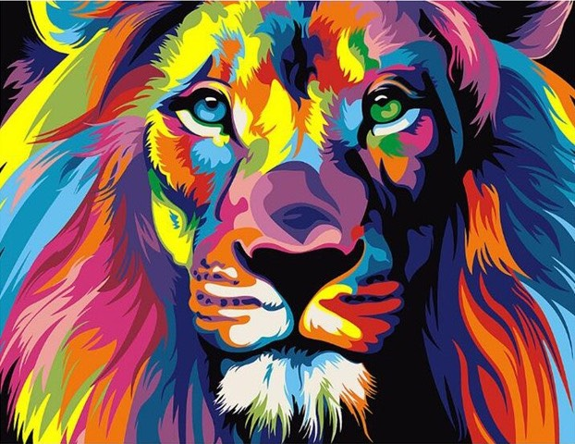

KHEMS PreK 3/4 School Supply
Wish List 2022-2023

- Full-size Backpack large enough to carry your child's daily binder and lunch box (no rolling backpacks please)
- School Uniform
- Change of clothes (at least 2 complete clothing sets including underwear and socks) in a large ziplock bag with your child's name labeled on the outside. 1 pair of Sneakers is mandatory!
- If not potty trained, a bag of diapers / Velcro sided pull-ups and wipes
- Nap items: child-size blanket or towel and a cot/crib sheet (no pillows please)
- Named Water bottles with water only each day
Additional Wish List Items (Greatly Appreciated!!!) ☺

Classroom Wishlist items | Individual Student wish list items  (in child’s favorite color)
Clorox/Lysol disinfectant wipes | 4 ounce Playdough tub
Paper towels | Roll of masking tape/painter’s tape
Kleenex facial tissue | Loop scissors – Amazon link
Hand sanitizer | Crayon rocks – Rainbow resource link
Copy paper - white or colored | 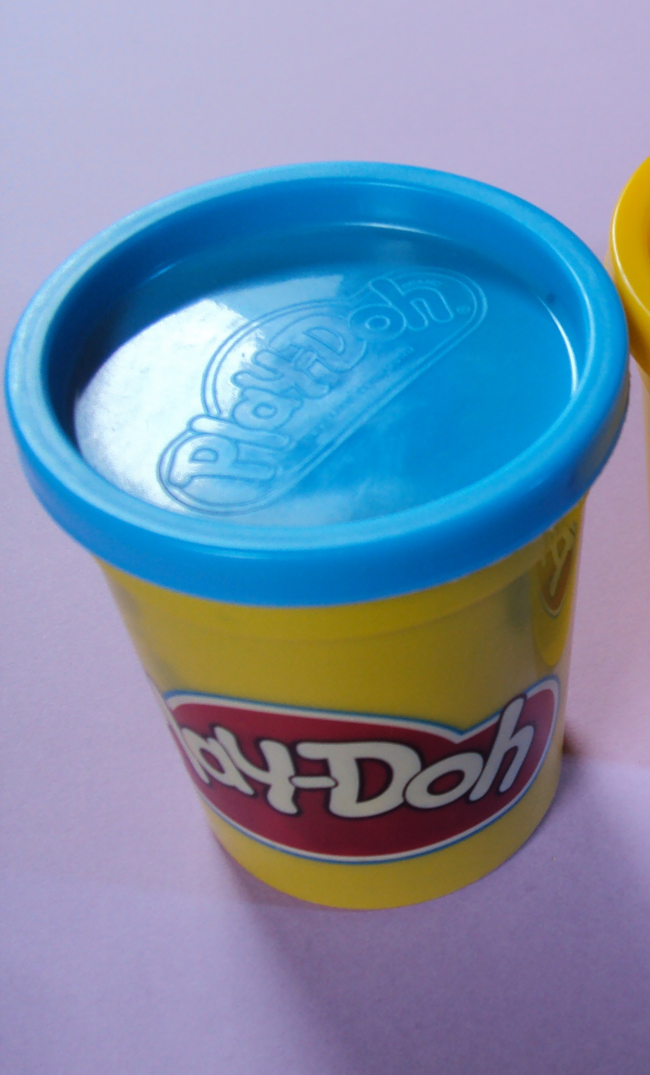  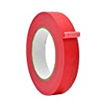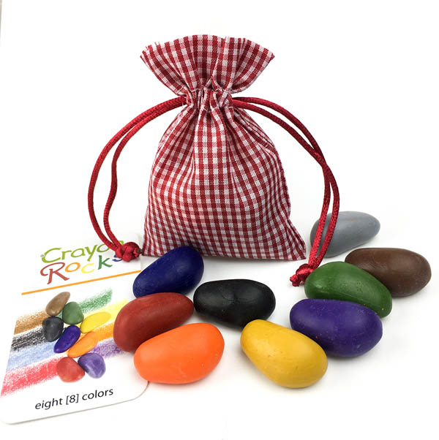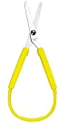  Playdough, masking tape, crayon rocks, loop scissors.
Velcro with sticky back
Ziplock bags – all sizes
Card stock – white or colored

Any Gift Cards: Office Depot, Wal-Mart, Target, Michaels,
Joanne Fabrics, Visa, American Express*, Amazon

If you would prefer to order your supplies on Amazon.com, we have created a list that you can refer to and add or remove items to suit your family budget. We appreciate your time and hope this makes starting school a little easier!
https://www.amazon.com/hz/wishlist/ls/2SCT0ICLE3VPX?ref_=wl_share

